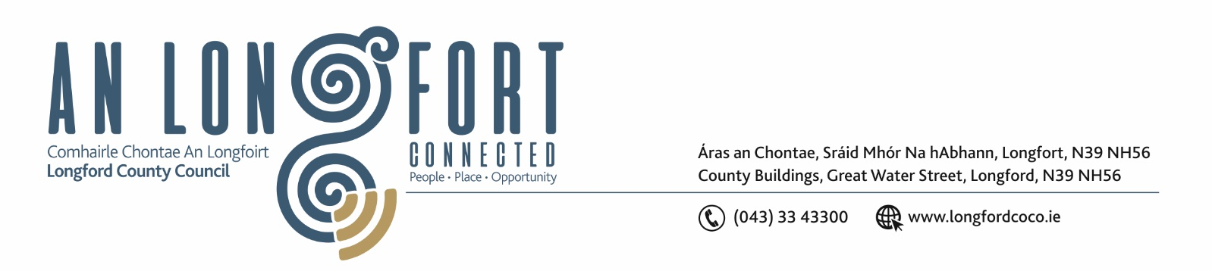

25th Iuil 2019.

Chuig: Gach Ball don Chomhairle.

A Chomhairleoir,

Iarrtar ort bheith i láthair ag Cruinniú Speisialta Chomhairle Chontae Longfoirt a tionólfar i Seomra na Comhairle, Aras an Chontae, Longford ar an Chéadaoin, 31u Iuil 2019 ag 3.00 p.m chun gnó a dhéanamh d’réir an Chláir thíos.

You are requested to attend Special Meeting of Longford County Council to be held in the Council Chamber, Aras an Chontae, Great Water Street, Longford on Wednesday, 31st July 2019 at
3.00 p.m. to transact business, as set out on the Agenda hereunder.

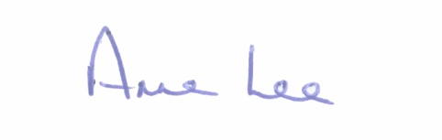
Mise le meas,

__________________
Anne Lee,
Meetings Administrator.

C L A R

1. To discuss Temporary Closure by ESB of the Lanesboro Power Plant and associated announcement by Bord na Mona.



